PYTHON
Python is a high level language and the compiler translates into machine or low level language so that computer can easily understand it.
It is case sensitive language.
Implicit Typed Language (we do not write types while defining variables)
PRINTING
How to print something in the terminal?
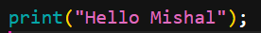
Output:
Explanation:
Print () is a function in Python. Whatever we write inside the parenthesis and double quotes will be printed as it is.
How to Print statements (sentences) on the same and different lines?
We can print statement in different lines by writing the print () multiple time.
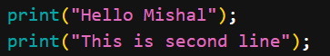
Output:
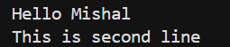
However we can use one print() function and write multiple statements in it. But that output will be written in a single line.
Output:
How do we print numbers in python?
In order to print any number as it is we use the print() function without using double quotes.
Output:
19
Note: In python no terminator is used at the end of the statement.
How do we print the sum of numbers?
We can simply use + to add two numbers.
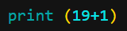
Output:
20
Note: All other operations (-, *, /) are also allowed and can be done in the way mentioned above.
Python Character Set
- Letters A to Z and a to z
- Digits 0 to 9
- Symbols + - * / etc.
- Whitespaces – Blank spaces, tab, carriage return, newline, formatted.
(Because we can use all the characters in English and all the keys present in the keyboard, we call python Close-to-human-language or close-to-English).
Variables
It is the name given to a memory location in a program. Its values can be changed i.e. it varies.
Note:
- We put the value at right in the container at left.
- The sign = is known as Assignment operator
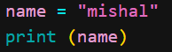
Here in first line variable “name” is storing “mishal” and second line of code prints the value present in the variable “name”.
Output:
Similarly ,
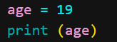
Output:
19
We can print a whole sentence using the value of variable like this
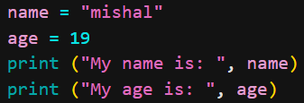
Output:
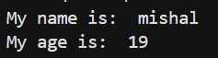
We can assign a variable another variable
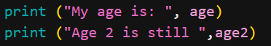
Output:
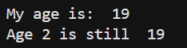
Age 2 is still 19 because in “age2” variable we assigned the variable “age” which has 19 stored in it already.
Rules For Identifiers:
- Identifiers can be combination of uppercase and lowercase letters, digits or an underscore (_). For Example: myVariable, Variable_1, variable_for_print all are valid python identifiers.
- An identifier can not start with digit. So, variable1 is valid but 1variable is not valid.
- We can not use special symbols like !, @, #, %, $ etc in out identifiers.
- Identifiers can be of any length. But they should be meaningful, short and simple to understand.
Type () Function
When you store any value in a variable python immediately find out the type of that variable. And we use type() function to find the type of the variable.
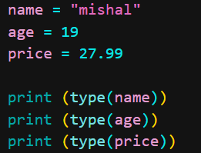
Output:
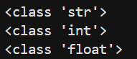
Now we can tell that every variable is storing different type of values that are string (str), Integer(int) and float (decimal values) respectively.
So these types are called Data Types
Some primary data types of Python:
- Integers (Stores whole numerical values that can be +ve, -ve and 0) - int
- String (Stores sentence or word and can be written inside single, double and triple quotes)
- Float (Stores decimal values)
- Boolean (stores true and false only T of true and F of false must always be capital)
- None (It represents that no value is stored in a variable)
Keywords
Keywords are reserved words in Python
and | else | in | return | as | except
is | assert | finally | lambda | try | True
break | False | nonlocal | with | class | for
None | while | continue | from | not | yield
def | global | or | del | if | pass
elif | import | raise | - | - | -
Note: We can not use there keyword for our identifier.
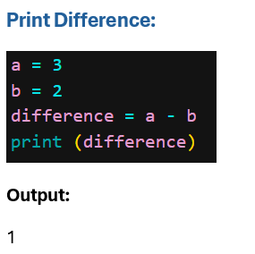
Print sum:
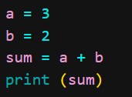
Output:
5
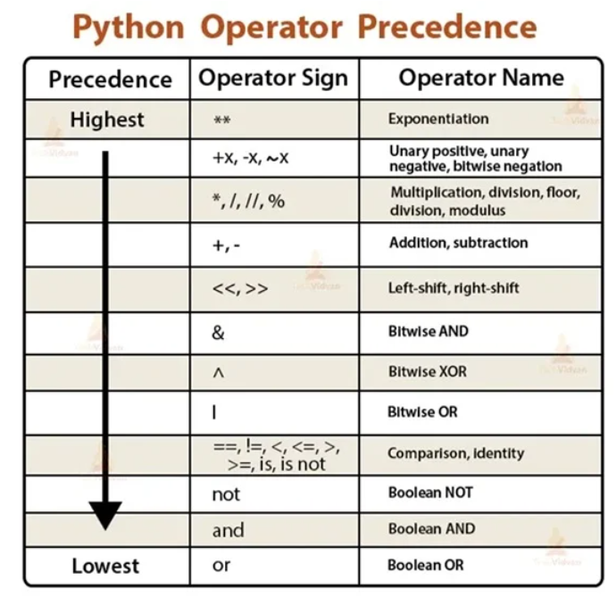
Types of Tokens
Punctuator
Punctuators are symbols to organize sentence structure in programming
(), {}, @, [], # etc
-=, +=, /=, *=, //=, = etc (Augmented Assignment Operators).
Expression Execution
- String and numeric values can operate together with *
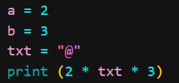
Here string is being multiplied by numeric values.
When this happens, all numeric values multiply and then the answer is the numerber that tells how many times a string will be printed.
Here 2*3=6 so string “@” will be printed 6 times.
Output:
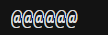
- String and String values can operate together with +
(also known as Concatenation)
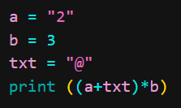
Parenthesis are solved first so we get 2@ and this 2@ will be multiplied by b whose value is 3 so 2@ will be printed 3 times.
Output:
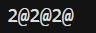
Note: “2” is a string and 2 is an integer and both are different.
- Numeric values can operate with all arithmetic operators
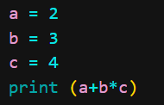
Output:
14
- Arithmetic expression with integer and float will result in float
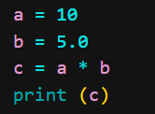
Output: 50.0
- Result of division operator with two integers will be float
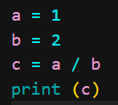
Output: 0.5
- Integer Division with float and int will give int displayed as float
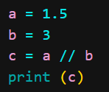
Integer division is a division that divide the numbers for example if we divide a with b we will get 0.5 as an answer but integer division will round off the answer to the smallest number.
0.5 -> 0.0
0.9999 -> 0.0
1.2 -> 1.0
And the final answer will always be in decimal form.
Output:
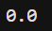
Floor Function :
Floor first finds the closest integer and that value will always be less than and equals th the float value
  - -> 1
5.2 -> 5
-5.2 -> -6
5.0 -> 5
Result of (a//b) is same as floor(a/b)
- Remainder (% - modulo) is -ve when denominator is -ve
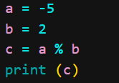
Output: 1
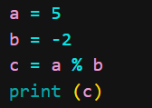
Output: -1

COMMENTS
Comments are the part of code which are not compiled by the compiler just like we have a section of rough work when we do maths.
- Single Line Comments
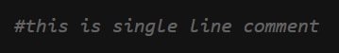
- Multiple Line Comments
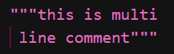
INPUT
input() statement is used to accept values (using keyboard) from user.
- String Input
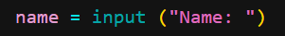
Int input
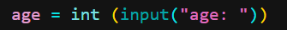
- Float input
CONDITIONAL STATEMENTS
Syntax:
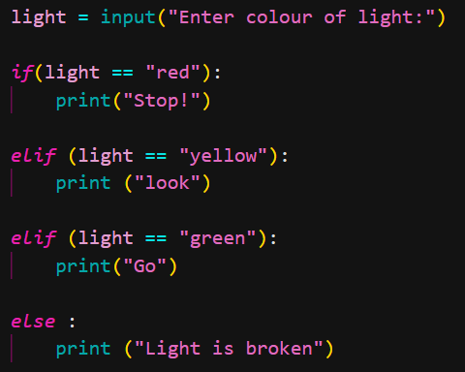

Ternary Operator (Single line if) :
Syntax :
<var> = <val1> if <condition> else <val2>
Example 01:
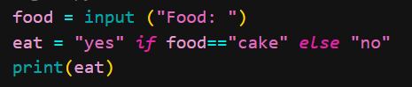
Output:
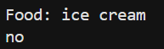
Example 02:
Output:
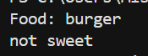
TYPES OF OPERATORS:
An operator is a symbol that performs a certain operation between operands (values on with we perform the operations).
- Arithmetic Operators (+, -, *, %, **)
- Relational Operators / Comparison Operators (==, !=, >, <, >=, <=)
- Assignment Operators (=, +=, -=, *=, /=, %=, **=)
- Logical Operators (not, and or)
TYPE CONVERSION
When we convert one type of variable into another type of variable, we call this Type Conversion.
- Conversion:
It is automatically done by compiler in Python.
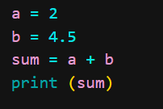
Here int is converted into superior value that is float so the output will be 6.5 (i.e. implicit conversion)
- Casting:
Manual Conversion.
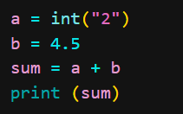
Output: 6.5
Type casting can only be done if variable contains data that can be fit into new type as shown above.
String value is 2 that can be detected as number and can be converted into int easily however if we have name we can not convert into numeric values.
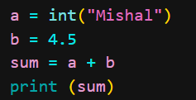
Output:
STRINGS
String is a datatype that stores a sequence of characters
Defined inside single, double and triple quotes.
In order to print string in two lines we can use escape sequence characters (helps in formatting)
Here /n is next line space sequence character.
Basic Operations of Strings:
- Concatenation
Joins two strings together.
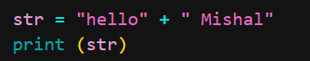
Output: Mishal Shehzadi
- Length of String
We can find out length of the string using len() function in Python.
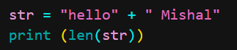
Output: 12
We count spaces as well.
Indexing:
Each character of the string gets number and this numbering start from 0.
M I S H A L
0 1 2 3 4 5
Indexes help us access the characters. We can not manipulate or change them through indexes.
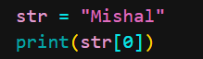
Output: M
Slicing:
Accessing parts of a String
Syntax:
Str [starting_index : ending_index]
(ending index is not included)
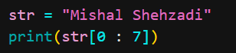
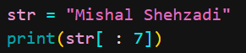
Output: Mishal
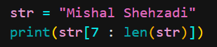
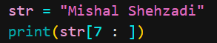
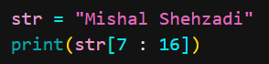
Output: Shehzadi
Negative Index:
We can write -ve index. It starts from -1 but it will be the index from last. We skip the last characters.
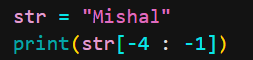
Output: sha
We do it when we do not know about the length of the string and we want to count our characters from last.

Other String Functions
- endswith () :
It returns true and false only.
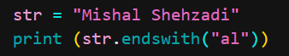
Output: False
- capitalize () :
Capitalizes first character of String. It does not change the real String
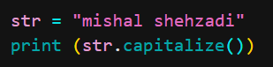
Output: Mishal shehzadi
However we can make the changes to the original string by storing the changed string into the same variable.
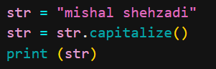
Output: Mishal shehzadi
- replace () :
Replaces old value with new value.
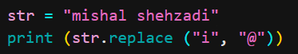
Output: m@shal shehzad@
- find () :
Search a specific word in the string. If exists then this function returns the first index of the first value.
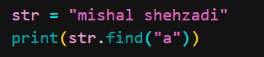
Output: 4
Note: if we search a word or character that does not exist we will get -1 as the output/
- count () :
Counts the occurrences of the substring in the String.
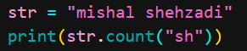
Output: 2
List in Python
A built in data type that stores set of values
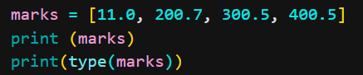
Output:
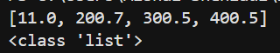
How is list in python different from arrays of other languages?
Python can store elements of different types (integer, float, string etc)
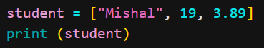
Output:
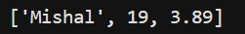
What is the major difference between list and String?
Strings are immutable in Python (immutable means not changeable).
Lists are mutable in Python (changeable)
List Slicing:
Similar to that of string slicing.
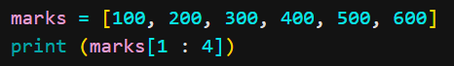
Output:
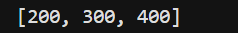
List methods:
append ():
Adds one element at the end
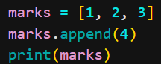
Output:
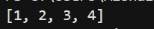
sort():
sorts in ascending order
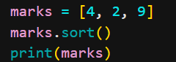
Output:
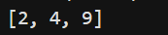
sort(reverse=True):
Sorts in descending Order
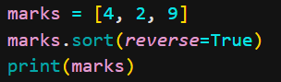
Output:
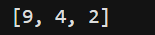
Similarly,
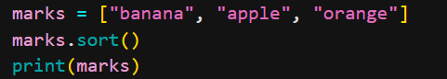
Output:
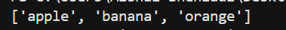
This is done in alphabetical order.
reverse():
Reverses the list
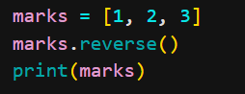
Output: [3, 2, 1]
insert():
Insert element at index.
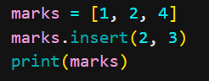
Output:
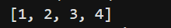
remove():
removes first occurrence of element
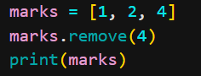
Output:
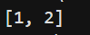
pop():
removes element at index
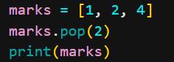
Output:

TUPLES
A built in data type that lets us create immutable sequences of values. (list is mutable).
In order to make tuples, we use () instead of []
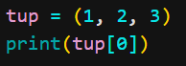
We cannot change any element at any index.
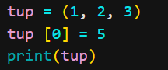
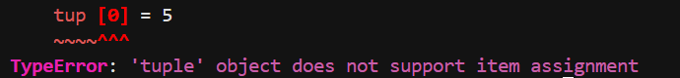
Empty tuple is valid.
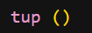
If we write only one element in the tuple it is not considered until we place a comma after that element.
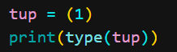
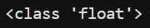
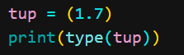
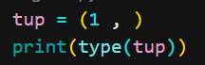
Tuple methods
index():
returns index of first occurrence
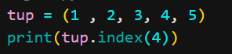
Output: 3
count ():
count total occurrences
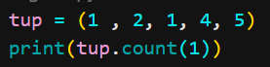
Output: 2
Dictionary In python
Dictionaries are used to store data values in key:value pairs
They are unordered(no index), mutable (unchangeable) & do not allow duplicate keys
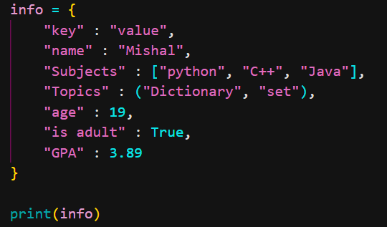
Output:
Keys can be string, bool, float, int.
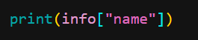
Output: Mishal
We can change values as well.
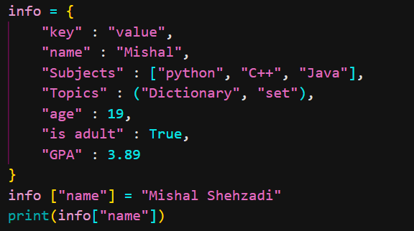
Output: Mishal Shehzadi
New key and value can be entered .
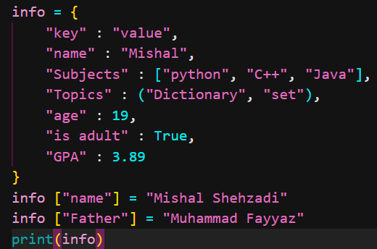
Output:
We can create empty dictionary in python
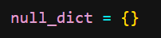
Nested Dictionary:
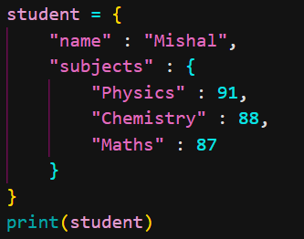
Output:
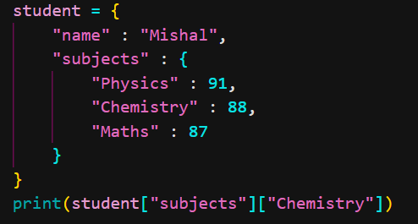
Output: 88

Dictionary Method:
keys():
returns all keys
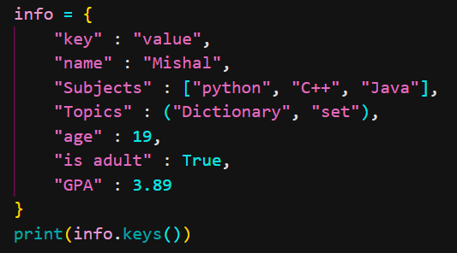
Output:
Not for nested keys.
values():
returns all values
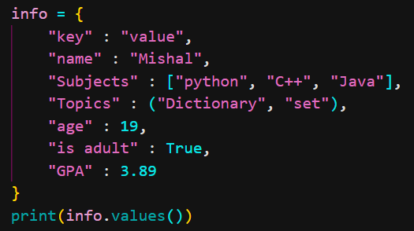
Output:
items():
returns all key:value pairs as tuple
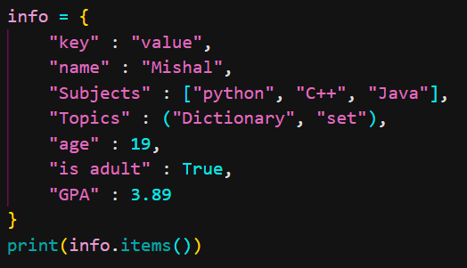
Output:

get():
returns the key according tot he value
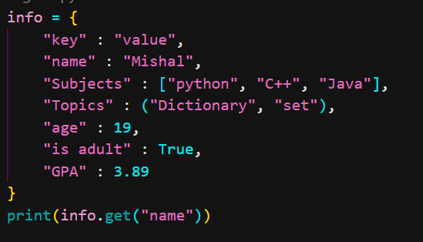
Output: Mishal
update():
inserts thw specified items to the dictionary
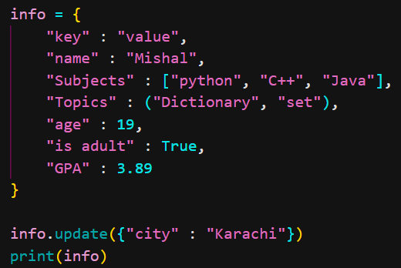
Output:
Set in Python
Set is the collection of unordered items(no index).
Each element in the set must be unique and immutable.
Empty set can be written as
null_set = set()

if we write
null_set = {}
this is empty dictionary and not a set.

Lists and dictionaries can not be stored in set because they are mutable.
Simple set can be made and printed in the following way:
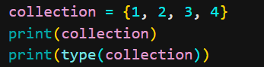
Output:
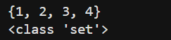
We can store different values in the set which means string can be storoed in the above example as well.
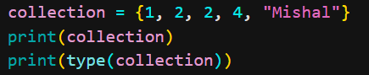
Output:
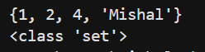
Repeated elements stored only once. Here length is 4 and not 5.
Sets in output are printed in different order. It is not necessary we get the same order as output all the times.
Outputs:
Set methods:
add():
adds an element
Set elements are immutable however set itself is mutable. We can pass tuple but not lists and dictionaries.
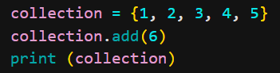
Output:
remove():
removes the element
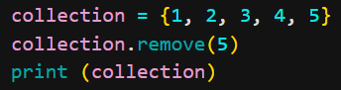
Output:
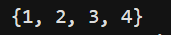
clear():
empties the set
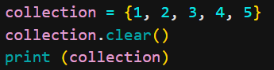
Output:
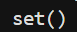
pop():
removes a random value
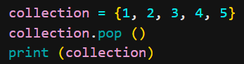
Output:
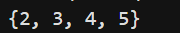
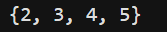
union():
combines both set values and returns new.
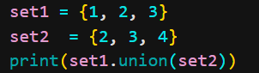
No changes take place in the original sets.
Output:
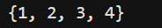
intersection():
combines common values and returns new
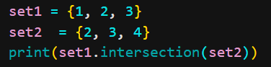
Output:
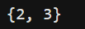
Loops in Python
Loops are used to repeat instructions.
Stopping condition is necessary otherwise infinite loop will run.
- While loop
Syntax:
while(condition) :
#remaining code
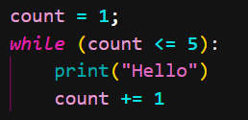
Output:
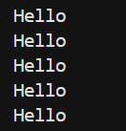
Running in loop is known as iteration.
First iteration means first run of loop.
Count in this example is iterator.
Break:
Used to terminate the loop when encountered.
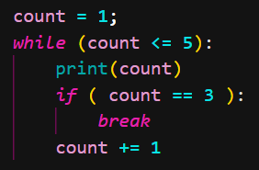
Output:
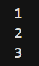
Continue:
Terminates execution in the current iteration and continues execution of the loop with the next iteration.
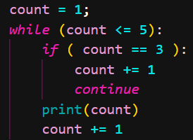
Output:
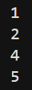
- For loop
Generally used for sequential traversal. For traversing list, String, tuples etc.
Syntax:
for el in list:
#code
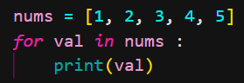
Output:
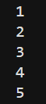
We can use optional else as well with for loop
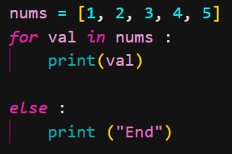
Output:
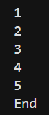
Range ():
Range function returns a sequence of numbers, starting from 0 by default, and increments by 1 (by default), and stops before a specified number.
range ( start?, stop, step? )
start and step are optional
Output:
Similarly we can print the numbers as well.
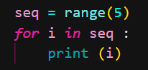
Output:
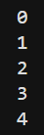
Important points:
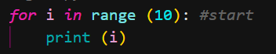
0, 1, 2, 3, 4, 5, 6, 7, 8, 9 will be the output
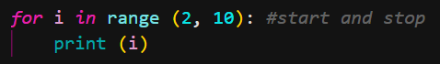
2, 3, 4, 5, 6, 7, 8, 9 will be the output
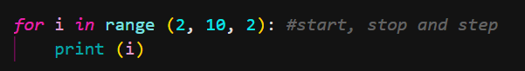
2, 4, 6, 8 will be the output
Pass Statement:
Pass is a null statement that does nothing. It is used as a placeholder for future code.
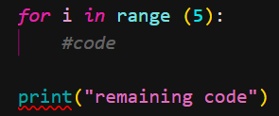
Output:
Correct way is
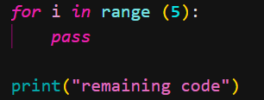
Output:

Functions in Python
Block of statements that perform a specific task.
When a part of code is repeated (redundant) we use functions.
Syntax:
Function Definition:
def func_name (para1, para2):
#some work
return val
Function Call:
func _name (arg1, arg2)
Example:
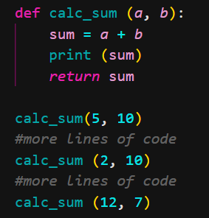
Output:
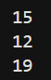
Types of functions:
Built-in Functions:
Some built in functions are:
- range ()
- print()
- type()
User defined Functions:
Function we make ourselves.
Default Parameters:
Assigning a default value to parameter, which is used when no argument is passed.
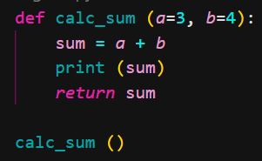
Output: 7 (default parameters)
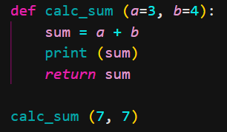
Output: 14
If we want to give the default value, we give it from the last
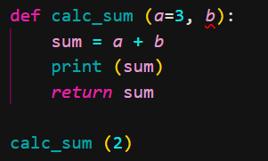
It show syntax error.
However,
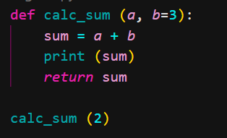
This is correct but we have to provide the value of argument when we are not setting the values of all parameters.

Recursion:
When a function calls itself repeatedly.
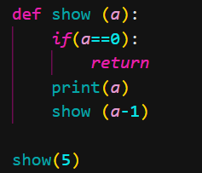
Output:
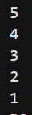
Here a==0 is a base condition (end condition) that tells the function when to stop working. It is important to write otherwise the function will never stop working.
Factorial Example:
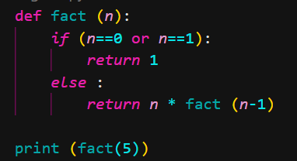
Output: 120
File I/O in Python
Python can be used to perform operations on a file (Read and write data)
Types of all Files:
- Text Files:
.txt, .docx, .log etc
- Binary Files
.mp4, .mov, .png, .jpeg etc
Open, read and close file:
We have to open a file before reading or writing.
Syntax:
f = open (“File_Name”, “mode”)
File_Name = full name of the file
mode = in which mode we are using the file, can be read (“r”) or write mode (“w”).
open () is a method.
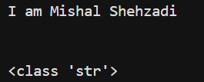
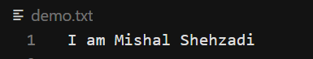
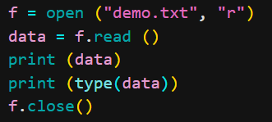
Some other characters and their meanings
characters | Meaning
‘t’ | Text mode (default)
‘x’ | Create a new file and open it for writing
‘a’ | Open for writing, appending to the end of the file is it exists
‘b’ | Binary mode
‘+’ | Open a disk file for updating (reading or writing)

read() -> reads the entire file
read (5) -. Reads the starting 5 characters from the file
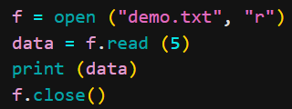
Output: I am
readline () -> reads one line at a time
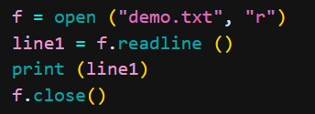
Output:
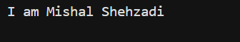
The space here is because in out txt file at the end of each line there is a character \n
Second line can be printed as
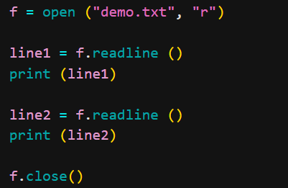

Output:
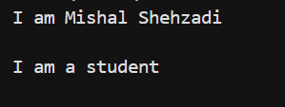
Text File:
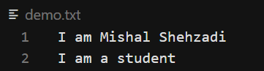
Writing to a file:
“w” mode overwrites the content of the file however “a” mode append so nothing overwrites.
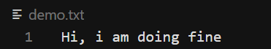
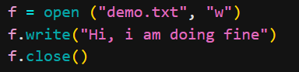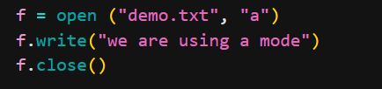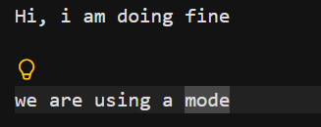
When a file doesnot exist, python creates it.
With Syntax:
with open (“demo.txt”, “a”) as f:
data = f.read()
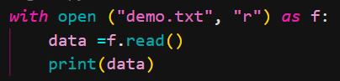
Output:
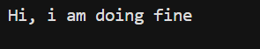
Deleting a file:
Can be done b using the os module.
Module (like a code library) is a file written by another programmer that generally has a function we can use.
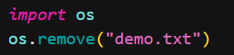
OOP in Python
To map withreal world scenarios, we started using objects in code.
This is called Object Oriented Programming.
It is used to reduce redundancy and increase reuseability.

Here green box denotes class and orange boxes are objects of this class. A class can have multiple objects.
In python, list and strings are objects.
Class:
Class is a blueprint for creating objects. Name of class is always a noun.
Class is a collection of attributes and methods.
Synxtax:
class Student:
name = “Mishal Shehzadi”
Objects:
In order to access class, we need objects. They are also known as instances
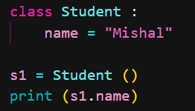
Constructor:
All classes gave a function called __init__(), which is always executed when the class is being initiated.
It is invoked everytime a new objects is created.
Constructor always take an argument which is known as selfparameter.
Default construtor are those that have only self parameters
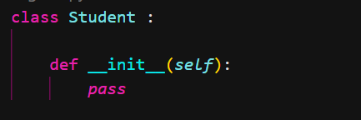
Examples:
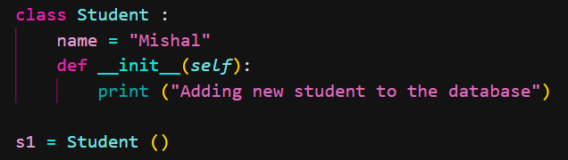
Output: Adding new Student to the database
The following exa,ple is of parametrized constructor.
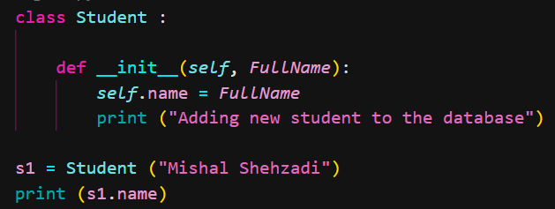
Output:
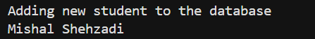
Self:
The self parameter is the reference to the current instance of the class, and is used to access variables that belongs to the class. 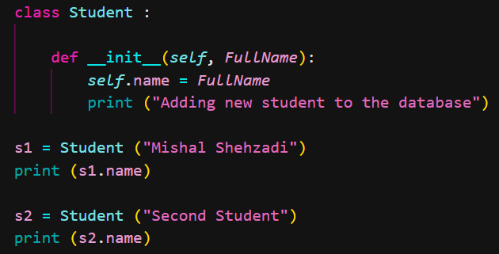
Output:
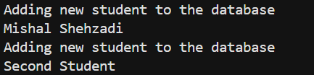
Class and Instance Attributes:
The data we store for an object is known as attributes(variables).
Class attributes are common for all the objects. Will be defined outside the constructor. Stored in the memory for only one time.
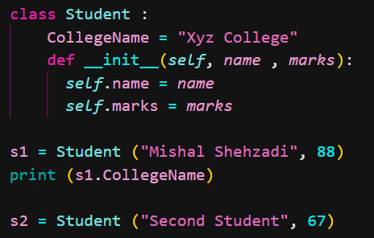
Output: Xyz College
Instance attribiutes are different for each object. For exmaple name of the students are almost different so name is instance attribute. It is defined by self.
Notes: Precedence of object attribute is hugher than class attribute
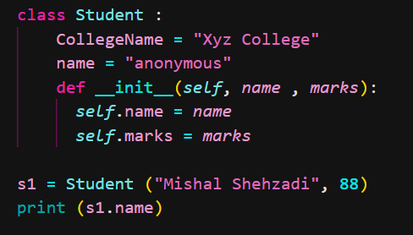
Output: Mishal Shehzadi
Methods:
Methods are functions that belong to the objects. Usually are verbs.
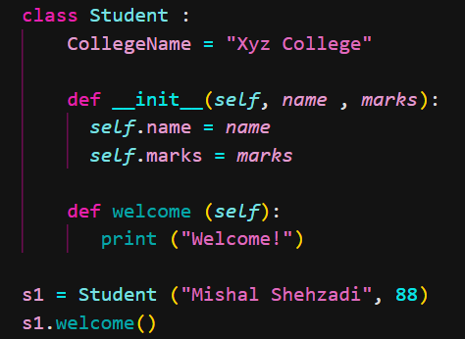
Output: welcome!
Static Methods:
Methods that dont use the self parameter (work at class level)
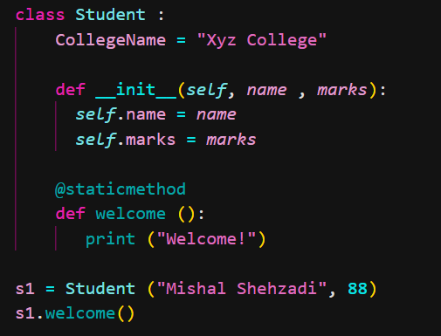
@staticmethod is a decorator that converts a normal method to static methods.
Decorators:
Allow us to wrap another function in order to extend the behaviour of the wrapped function, without permanently modifying it.
Pillars of OOP
- Abstraction
- Encapsulation
- Inheritance
- Polymorphism
Abstraction:
Hiding the implemetation details of a class and only showing the essential deatures to the user.
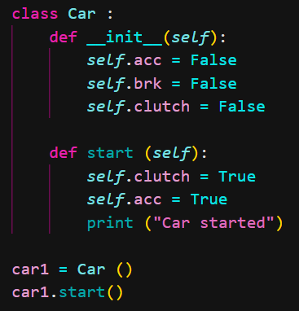
Here we can not tell what is happening behind the code, we just get the message in the output “car started”.
Encapsulation
Wrapping data (variables) and methods (functions) into a single unit (object).
Inheritance:
When one class (child/derived) derives the propertiesand methods of another class (parent/base).

Types of Inheritance:
- Single Inheritance
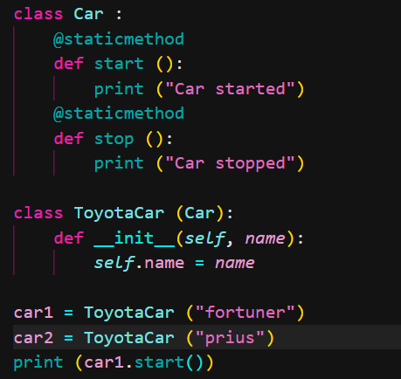
- Multi-level inheritance
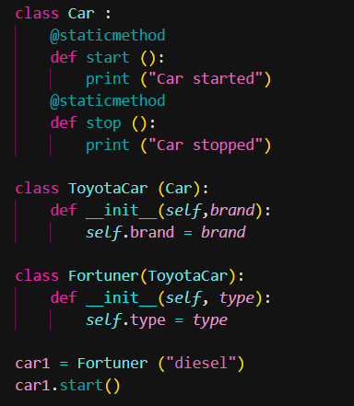
- Multiple Inheritance
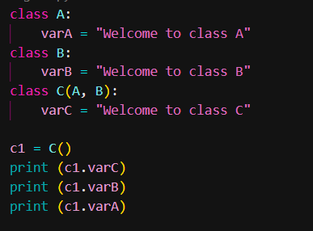

Polymorphism:
Poly -> many
Morphs -> forms
Operator Overloading:
When the same operators are allowed to have different meaning according to the context.
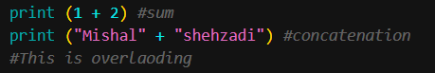
Super method:
super() method is used to access methods of the parent class.
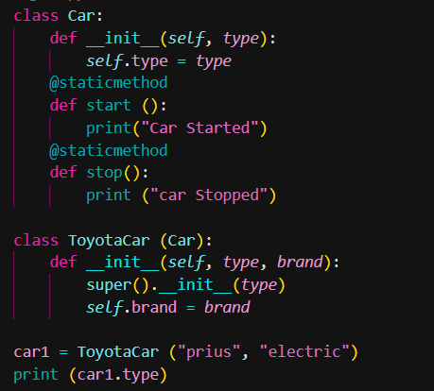
Output: prius
del keyword:
used to delete object properties or object itself
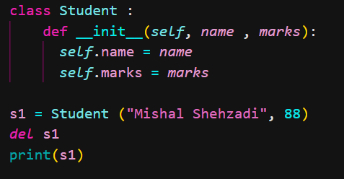
Error:
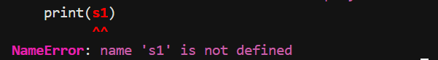
Private (like) attributes and methods:
They are meant to be used only within the class and are not accessible from outside the class.
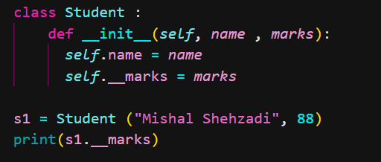
Two underscore helps to achieve tthis feature.
Error:
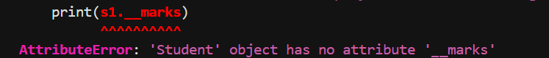
Class method:
A class method is bound to the class and receives the class as an implicit first argument.
Note: static method cant access or modify class state and generally for utility.
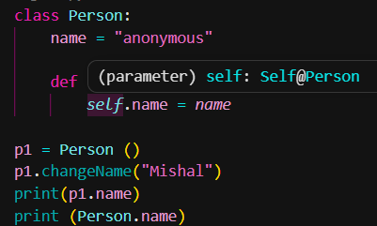
No class attribute is changed.
Output:
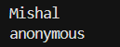
But, we can change the class attribute.
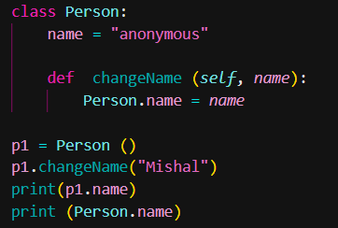
Output:
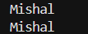
So we use @classmethod decorator with a parameter cls
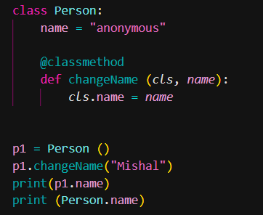
Output:
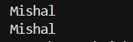
Property Decorator:
when the value of an attribute is dependent pn the function then we can amke this function our property.
One way to solve a problem:
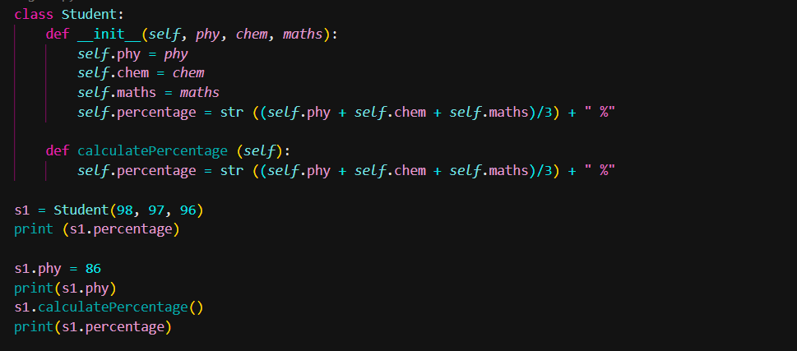
Here when we did not make calculate percentage function we tried to chnage the value of phy which was done easily but the percentage will be calculated from the phy marks that were inserted before therefore we make calculatepercentage fucntion that changes the value of phy from everywhere and we get the percenatge according to the new marks.
This work can be done by @property.
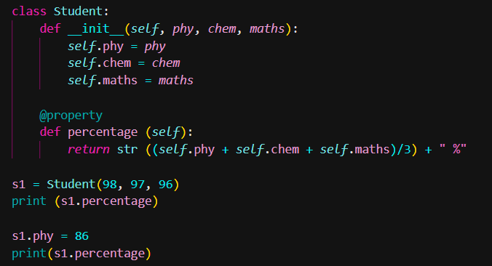
Output:
